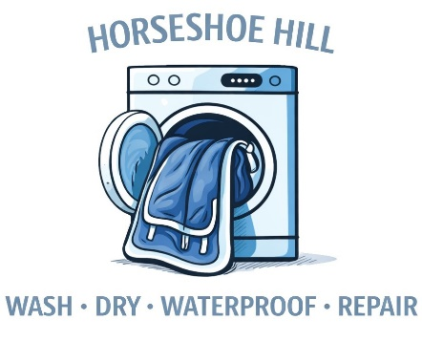

Thank you for choosing Horseshoe Hill Equine Laundry Services!
7588 Lower East Hill Rd Colden, NY 14033
Horseshoehill716.com
horseshoehill716@gmail.com
716-325-2165
Instructions
- Bag or tie up you blankets and label them with your last name on the outside of the bag or bundle. Please do your best to remove dirt, manure, and hair prior to sending items for cleaning.
- If dropping off/picking up yourself please call, text, or email us to set a time at our location.
- If scheduling a pick up/drop off delivery please call, text, or email us to set a time and location.
- Upon drop off or us picking up your blankets we will review the services list to ensure all desired services are completed. At that time please notify us of the following:
  - List of items that are in your order. For example: describe the color, weight, and size of each blanket, the number of polos, standing wraps, or towels in your bulk order, or the size and color of your dog bed. This list helps us ensure your order remains together and is all returned to you.
  - Notify us of any known damage to items being sent for washing. This is for administrative purposes and does not mean you will be charged for a repair unless indicated on the service list.
  - Indicate items you would like waterproofed. Waterproofing will not be completed on any item unless it is noted in description section.
  - If a preclean is not requested and items require this service, we reserve the right to add precleaning charges for each item received with excess mud, manure, or hair.
  - Indicate repairs you would like completed and specify which blanket requires the repair and the location of the repair needed. Repairs will not be made to any item unless selected and requested service is described.
  - Notify us of any special requirements for washing or handling an item such as cold wash only.
- We accept cash, checks, Venmo, and credit cards. Please note blankets will not be returned until payment is received. Payments made via credit card and Venmo will have an 2.99% service charge added to the total.
  - Checks can be made out of Horseshoe Hill LLC. Venmo: @horseshoehill
- Please ensure you review our terms of service for equine laundry services on our website horseshoehill716.com

Name: ____________________________________________________________________________
Address (if applicable): _______________________________________________________________
__________________________________________________________________________________
Phone Number: ________________________________Email: _______________________________

Please Circle One: Self Drop Off/Pick Up Delivery Pick Up/Drop Off
If paying by credit card or Venmo please initial this box to indicate you understand a 2.99% service charge will be added to your total:
Please initial this box indicating you understand the additional fees that can be incurred for precleaning or for blankets not picked up or scheduled for delivery within 30 days of notice of service completion:
How would you like to be notified when your items are ready for pick up or delivery?
Please Circle One: Call Text Email

Please sign below indicating you understand the above information and that you read and understand Horseshoe Hill’s terms of service for laundry and repairs. By signing you also indicate that we reviewed with you the order inventory list and service form indicating the services you would like completed and that you give Horseshoe Hill permission to complete said services.

Name Printed: __________________________________________________________
Name Signed: ___________________________________________________________
Date: __________________________________________________________________
Thank you for choosing Horseshoe Hill Equine Laundry Services!

